Idaho Ground Water Association
IGWA assists, promotes, encourages and supports the interests and welfare of the Ground Water Industry within the State of Idaho
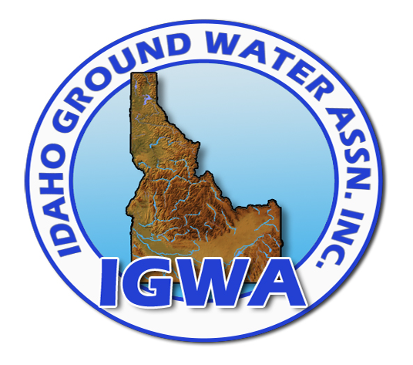
Membership Form – 10/01/11–9/30/12

Name
Organization
Address
City/St/Zip
Phone
email
Please make check payable to and mail with this form to: IGWA P.O. Box 2624 Boise, ID 83701
Contractor—$100
Any person, partnership, form, or corporation that is a contractor in the Ground Water Industry
Associate—$40
Persons employed by a Ground Water Contractor member, having an interest in the purposes and objectives of the IGWA
Manufacturers & Suppliers—$100
Any person, firm or corporation engaged in manufacturing or selling ground water equipment of supplies, including non-residents
Technical—$70
Any person who is interested in the Ground Water Industry such as geologists, hydraulic engineers, etc.

